**Cryptocurrency Portfolio Optimization**

Rohit Garg ([f2005636@gmail.com](mailto:f2005636@gmail.com))

**Cryptocurrencies**

A cryptocurrency a digital asset designed to work as a medium of exchange that uses cryptography to secure its transactions. Cryptocurrencies are classified as a subset of digital currencies and are also classified as a subset of alternative currencies and virtual currencies.

For demonstration purposes, we have fetched the following cryptocurrencies from Kaggle dataset (https://www.kaggle.com/sudalairajkumar/cryptocurrencypricehistory/data). The observation window is from 20-Aug-2016 to 20-Feb-2018.

* Bitcoin (BTC)
* Ethereum (ETH)
* Ripple (XRP)
* Litecoin (LTC)
* Monero (XMR)
* DASH (DASH)
* NEM (XEM)

|  |  |
| --- | --- |
| **R Code to calculate the continuous returns** | assets = data[, -1]  return = log(tail(assets, -1) / head(assets, -1)) |

**Table 1: Data Summary of Close Price**



**Table 2: Data Summary of Returns**



**Table 3: Comparison of Volatility**



**Figure 1: Close Price and Daily Return**

|  |  |  |
| --- | --- | --- |
| **Bitcoin (BTC)**  Prevailing bitcoin logo |  |  |
| **Ethereum (ETH)**  C:\Users\rg83892\Desktop\download.png |  |  |
| **Ripple (XRP)**  Ripple logo.svg |  |  |
| **Litecoin (LTC)**  6 Full Logo S-2.png |  |  |
| **Monero (XMR)**  Monero-Logo.svg |  |  |
| **DASH (DASH)**  https://upload.wikimedia.org/wikipedia/en/thumb/a/a6/Dash_%28cryptocurrency%29_logo.svg/220px-Dash_%28cryptocurrency%29_logo.svg.png |  |  |
| **NEM (XEM)**  NEM (cryptocurrency) logo.svg |  |  |

**Minimum Variance Portfolio**

For the mathematical formulation of Mean-Variance model by Markowitz, we need some definitions. They are explained as follows:

* By asset Xi, we mean a random variable with finite variance.
* By portfolio, we mean the combination of assets: P =­ ΣwiXi , where Σ­wi = 1
* By optimization, we mean a process of choosing the best wi coefficients (weights) so that our portfolio meets our needs (that is, it has a minimal risk on the given expected return or has the highest expected return on a given level of risk).

|  |  |
| --- | --- |
| **R Code to check the head and tail of returns** | head(return)  tail(return) |

**Table 4: Head of Returns Dataframe**



**Table 5: Tail of Returns Dataframe**



Minimum variance on a desired level of return: It is clear that wTQw is the variance of the portfolio and wr is the expected return. For the sum of the weights we have w1 =1, which means that we would like to invest 1 unit of cash.

**Equation 1: Minimum Variance**



It can be shown that this problem is equivalent to the following system of linear equations. Two rows and two columns are added to the covariance matrix, so we have conditions to determine the two Lagrange multipliers as well. We can expect a unique solution for this system.

**Equation 2: Linear Equation**

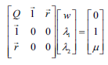

We start building the left side of the linear equality system specified at the Lagrange theorem, where we combine the covariance matrix (cov), ones repeated (rep) by the number of columns (ncol) in the dataset and the means (colMeans) of the returns as rows (rbind). Now, we also combine the last two rows of the matrix (tail) as new columns (rbind) on the left to make it complete for the linear system with the extra zeros specified in the Lagrange theorem (matrix of 2x2):

|  |  |
| --- | --- |
|  | Q = rbind(cov(return), rep(1, ncol(assets)), colMeans(return))  Q = cbind(Q, rbind(t(tail(Q, 2)), matrix(0, 2, 2)))  round(Q, 5) |

**Table 6: Left Part of the Equation**



Next, we build the right side of the linear equality system. Expected return (mu) is 0.005 and ones repeated (rep) by the number of columns (ncol):

|  |  |
| --- | --- |
|  | mu = 0.005  b = c(rep(0, ncol(assets)), 1, mu)  round(b, 5) |

**Table 7: Right Part of the Equation**



After successfully building the parts of the linear equality system, we are only left with the task of solving it. The result is the vector of optimal weights and the Lagrange multipliers to get the desired expected return with a minimal variance:

|  |  |
| --- | --- |
|  | w = solve(Q, b)  round(w,5) |

**Table 8: Weights**



**Tangency Portfolio**

If R (riskless asset) is added to X (any risky portfolio); then those portfolios form a straight line on the mean-standard deviation plane. Any portfolio on this line is available by investing into R and X. It is clear that the best choice for X is the point where this line is tangent to Efficient Frontier. This tangency point is called the market portfolio or tangency portfolio, and the tangent of Efficient Frontier of risky assets at this point is called Capital Market Line (CML), which consists of the efficient portfolios of all the assets in this case.

**Figure 2: Tangency Portfolio**

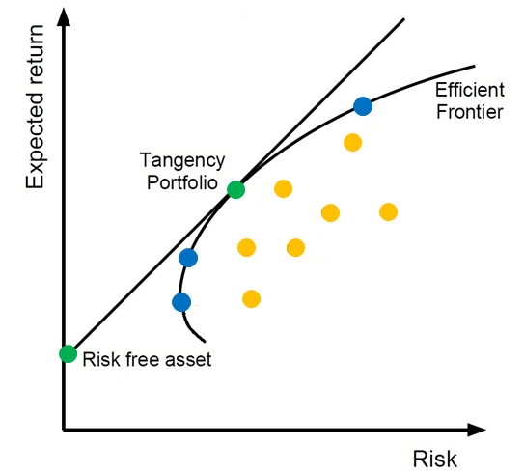

We can easily modify the variance minimization code to accomplish this. First of all, if we add a riskless asset, a full-zero row and column is added to the covariance matrix (where n is the number of assets including the riskless one). Then the riskless return (let rf be 0.0001) is added to the return vector.

|  |  |
| --- | --- |
|  | Q = cbind(cov(return), rep(0, n - 1))  Q = rbind(Q, rep(0, n))  Q = rbind(Q, rep(1, n), r)  Q = cbind(Q, rbind(t(tail(Q, 2)), matrix(0, 2, 2)))  round(Q, 5) |

**Table 9: Left Part of the Equation**



Next, we build the right side of the linear equality system. Expected return (mu) is 0.005 and ones repeated (rep) by the number of columns (ncol):

|  |  |
| --- | --- |
|  | mu = 0.005  b = c(rep(0, ncol(assets)), 1, mu)  round(b, 5) |

**Table 10: Right Part of the Equation**



After solving the equation, the result is the market portfolio. The sum of the weights is 1.

|  |  |
| --- | --- |
|  | w = solve(Q, b)  w = head(w, -3)  w / sum(w)  round(w, 5)) |

**Table 11: Weights**



**Summary**

The two approaches discussed in this paper for portfolio optimization are minimum variance portfolio and tangency portfolio. The weights for minimum variance portfolio and the weights for the tangency portfolio:

**Table 12: Weights**

